GIVING ADVICE

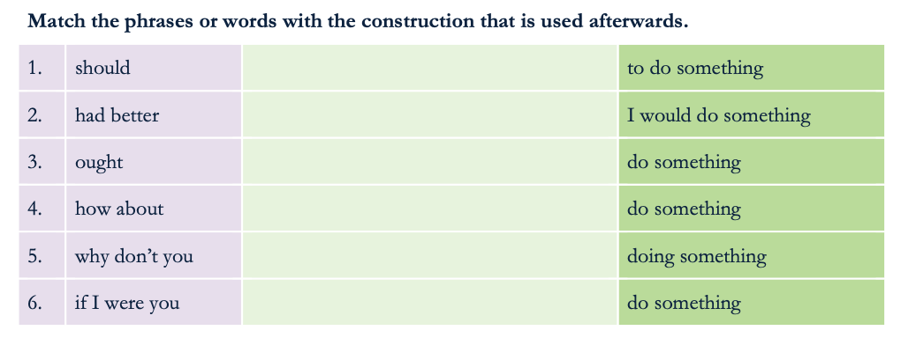

**do something**

**do something**

**to do something**

**doing something**

**do something**

**I would do something**

**Examples of the structures above in context.**

* If you want to study French, you **should start** learning it right now.
* If you want to lose weight, you shouldn’t eat so much chocolate.
* You **ought to** **drink** less alcohol.
* Why don’t you **come** jogging with me?
* **How about** go**ing** to the cinema?
* If I were you, I **would stop** smoking.
* You’**d better start** learning now, if you have an exam tomorrow.

**MORE PHRASES**

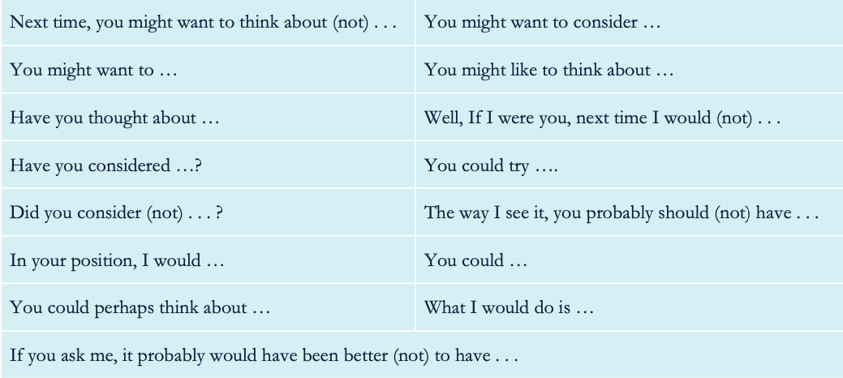

**Practise the words and phrases in the situations below:**

**1. Your friend wants to lose weight.**

-You should do exercise

**2. Your colleague is not happy with his workplace.**

-Have you consider talking with you boss

**3. Your best friend is not happy with her boy/girlfriend.**

-You could broke with her

**4. Your sister doesn’t know if she wants to buy a house or a flat.**

-In your position I would buy a house with yard

**5. Your son wants to study languages.**

-